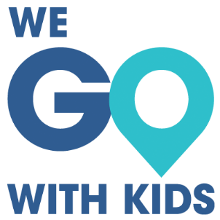 |  |  | Ultimate Packing List  Miscellaneous
Medicine |  | Me |  |  | Beach
First Aid Kit |  | Toiletry Bag |  |  | Towels
Thermometer |  | Brush |  |  | Snorkels / Fins
Ibuprofen |  | Hair Products |  |  | Floaties
Allergy Medicine |  | Glasses and Case |  |  | Sand Toys
Vitamins |  | Contact Case |  |  | Beach Blanket
Prescription Medicine |  | Extra Contacts |  |  | Kite
 |  |  |  |  | Bathing Suit Cover
 |  |  |  |  | Goggles
Toiletries/Liquids |  | Baby
Face Soap |  | Diapers |  |  | Misc
Makeup |  | Wipes |  |  | Tickets
Contact Solution |  | Diaper Cream |  |  | Travel Info
Deodorant |  | Changing Pads |  |  | Books
Stain Remover |  | Blankets |  |  | Maps
Dish Soap |  | Lovey |  |  | Travel books
Laundry Detergent |  | Pacifier |  |  | Umbrella
Aloe |  | Carrier |  |  | Snacks
Sunscreen |  | Soap |  |  | Travel Pillow
Insect Repellent |  | Sippy Cups |  |  | Neck Pillow
Lotion |  | Snack Cups |  |  | Toys
Shampoo |  | Plastic Silverware
Nail Clippers |  | High Chair |  |  | Electronics
Chapstick |  | Pack ‘n Play |  |  | Phone + charger
 |  | Inflatable Bed |  |  | Ipad + charger
 |  | Stroller |  |  | Camera + batteries
 |  | Car Seat |  |  | GPS

Ultimate Packing List
Clothes
Clothes/Shoes |  | Kid #1 |  | Kid #2 | Kid #3 | Me
Short Sleeved Shirts
Long Sleeved Shirts
Shorts
Dresses
Pants
Pajamas
Underwear
Socks
Fleece
Swimming Suits
Shoes
Flip Flips
Toiletries
Toothbrush
Toothpaste
Gear
Coat
Rain Jacket
Hats
Sunglasses
Gloves
Base Layer
Boots
Rain Pants
Other
Passport
Headphones

