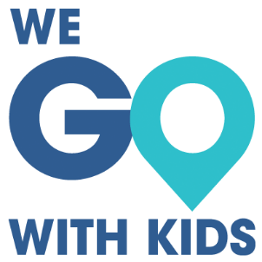 |  |  | Ultimate Packing List  Miscellaneous
Medicine |  | Me |  |  | Pool
First Aid Kit |  | Toiletry Bag |  |  | Towel
Thermometer |  | Brush |  |  | Goggles
Ibuprofen |  | Hair Products
Allergy Medicine |  | Glasses and Case |  |  | Misc
Vitamins |  | Contact Case |  |  | Tickets
Prescription Medicine |  | Extra Contacts |  |  | Travel Info
 |  |  |  |  | Books
 |  |  |  |  | Maps
Toiletries/Liquids |  | Baby |  |  | Travel books
Face Soap |  | Diapers |  |  | Umbrella
Makeup |  | Wipes |  |  | Snacks
Contact Solution |  | Diaper Cream |  |  | Travel Pillow
Deodorant |  | Changing Pads |  |  | Neck Pillow
Stain Remover |  | Blankets |  |  | Toys
Dish Soap |  | Lovey
Laundry Detergent |  | Pacifier |  |  | Electronics
Aloe |  | Carrier |  |  | Phone + charger
Sunscreen |  | Soap |  |  | Ipad + charger
Insect Repellent |  | Sippy Cups |  |  | Camera + batteries
Lotion |  | Snack Cups |  |  | GPS
Shampoo |  | Plastic Silverware
Nail Clippers |  | High Chair
Chapstick |  | Pack ‘n Play
 |  | Inflatable Bed
 |  | Stroller
 |  | Car Seat

Ultimate Packing List
Clothes
Clothes/Shoes |  | Kid #1 |  | Kid #2 | Kid #3 | Me
Short Sleeved Shirts
Long Sleeved Shirts
Pants
Pajamas
Underwear
Socks
Fleece
Swimming Suits
Shoes
Toiletries
Toothbrush
Toothpaste
Gear
Winter Coat
Rain Jacket
Hat
Sunglasses
Gloves
Base Layer
Boots
Rain Pants
Other
Passport
Headphones
Eye Mask

